Training Fiche Template

Title | Managing Digital Team
Keywords | Digital team / Smart working / Digital tools for management / Smart and digital leadership / Mobilising others
Provided by | IDP
Language | EN
Objectives | - Support women entrepreneurs in the managing of a digital team, through the acquisition of technical and practical skills  - Support the target group in reaching an advanced level of the EntreComp framework competences:  - Mobilising others  - Self-Awareness and self-efficacy
Learning outcomes | - Communicate clearly and effectively within a digital team  - Recognize a set of digital tools for team management  - Adopt the OKR methodology within a business/team  - Guarantee the work-life balance of the employees  - Compensate weaknesses by teaming up with others  (EntreComp comp.: Self-awareness & self-efficacy, Advanced Level)  - Inspire others and get them on board for creating value  (EntreComp competence: Mobilising others, Advanced level)
Training Area | Digital skills
 | Pricing and marketing
 | Access to finance from the female perspective
 | Leadership and Communication Skills
Content index | Module: Managing Digital Team  Unit 1: Smart Working  Section 1: Definition  Section 2: Golden rules  Section 3: ICT tools for Management  Unit 2: Team Management  Section 1: OKR methodology  Section 2: Tasks distribution  Section 3: Digital tools for communication  Section 4: Work life balance in a digital team  Unit 3: Leadership  Section 1: Smart and digital leadership  Section 2: Challenges  Section 3: How to motivate a digital team  Section 4: Productivity-boosting strategies
Content development | Unit 1: Smart Working  Section 1: Definition  Smart working has been defined as:  - A new way of working based on flexible work arrangements and an extensive use of information technologies that support employees to potentially work in any time and space;  - An agile and dynamic way of working that leads to high performance, increased productivity, and improved job satisfaction that result is a “triple-win” configuration for customers, employees, and organisations.  Using digital technologies to improve organisational effectiveness requires a broader intervention in management and leadership capabilities. Keep in mind that the essential elements for and effective and efficient smart working are:  - Agile Approach to Work  - Centrality of the employees  - Innovation  - Collaborative ecosystem  Section 2: Golden rules  - Have the necessary platforms, apps and resources. Assess the team necessities and hire or install the services needed for the correct execution of tasks;  - Keep a fair workload distribution and make sure that every team member knows which tasks correspond to her/him;  - Use video conference platforms periodically, to clarify tasks and information, also fostering a healthy and dynamic work atmosphere within the team;  - Keep communication open, assertive and effective.  Some Tips:  1. Always answer emails and messages to confirm that you received them;  2. Include the subject in every email to speed their classification and management;  3. Keep workmates posted and clarify any misunderstanding if needed;  - Plan meetings in advance in order to guarantee better effectiveness and organisation and avoid time incompatibilities.  Section 3: ICT tools for Management  A whole array of ICT tools might be used to improve business and team management in smart working. Here some of the most useful:  Dropbox  An all-in-one that offers project and file management, task lists, email, messaging, tracking and follow-up etc. It is completely customisable, letting users import information from other projects and managers.  Teamviewer  It enables remote access to other devices. It allows users to share and control their desktops, make online meetings, videoconferences and transfer files.  Even though a specific platform for each task would be optimal, platforms that encompass all functions are still a great option:  Monday.com  It allows for easy planning and management for most of the tasks of a business within the same workspace. This includes project and task management, CRM, marketing, design, human resource etc.  ClickUp  An all-in-one that offers project and file management, task lists, email, messaging, tracking and follow-up etc. It is completely customisable, letting users import information from other projects and managers.  Unit 2: Team Management  Section 1: OKR methodology  Objectives and Key Results (OKR) is a modern method for goal and people management, which particularly suits for digital team and digital business, since:  - It is based on the idea that motivation comes through ownership and self-organisation;  - It allows teams to react to changes in the market on their own initiative, to be self-organised and autonomous.  OKRs shall be clear to everybody within the team and are typically set every quarter to react quickly to changes.  Which is the difference between Objectives and Key results?  - Objectives are determined by managers and represent the overall qualitative goals of the company.  - Key results are determined by the employees in a bottom-up approach; they represent the quantitative objectives of the team  Exemple  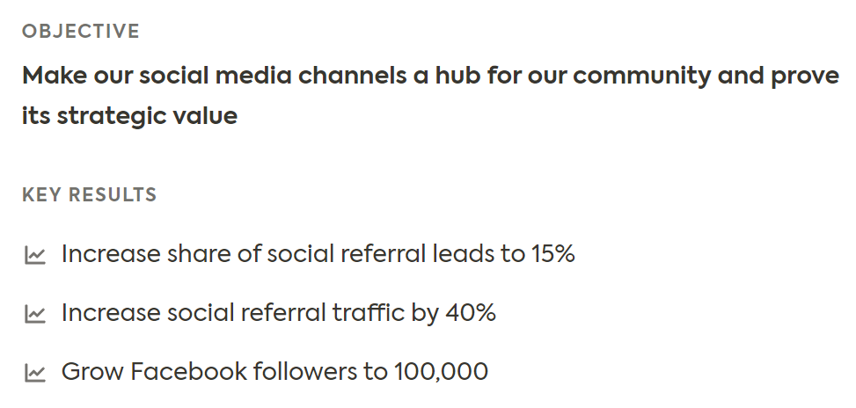  Source https://mooncamp.com/blog/okr-mbo/  Section 2: Tasks distribution  A correct task distribution is fundamental to guarantee proper business management and improve workers’ performance, in particular in smart working contexts.  These are some of the ICT tools which can help project planning and team management:  Asana  It offers details on tasks and projects and implements communication, organisation and planning in order to achieve team success.  Trello  It organises tools via Kanban tables, which allows for an enjoyable view of teamwork management.  Section 3: Digital tools for communication  In a digital team, it is essential to be in constant communication to perform all daily tasks in an effective and synchronised way.  Here some tools which can help to create a central place for communication:  Skype  Skype is an optimal choice for any company. Users can video call and chat via PC, tablets and smartphones. It gathers up to 50 people.  Jitsi  Jitsi is a free open source tool. Users can create a meeting without needing an account and invite participants sharing a URL.  Slack  Slack is a messaging app for companies, which enables conversation grouping, sorting them in threads or by topic in order to facilitate the access to any team information.  Video Conferences services  Zoom  In the free version, Zoom gathers up to 100 participants but the duration of a session is limited to 40 minutes. The Pro version costs 13.99 euros per month and per moderator.  Cisco Webex  Cisco Webex provides capabilities including online meetings, team messaging and file sharing. Users can join video conferences from a desktop or mobile app. A web version of Webex, with less features, is available as well.  MicrosoftTeams  MicrosoftTeams gathers up to 250 participants and online events with up to 10,000 participants. In addition to video conferencing, Teams offers extensive virtual collaboration features, including Office 365 integration.  GoToMeeting  GoToMeeting is an online meeting, desktop sharing, and video conferencing software package. It is available for the computer, but also as an app for smartphones and tablets.  Section 4: Work life balance in a digital team  Major flexibility in working schedule and the use of technologies facilitate the blurring of the line between work and personal life.  How to protect and improve employees’ work-life balance in smart working?  - Offer a flexible working time model;  - Clearly communicate time off for vacation time, community initiatives, health insurance and parental leave;  - Let employees take all their vacation days and give them weekends off (i.e., no answering emails, being able to switch the phone off at night);  - Encourage employees to commit to enjoying some downtime every day;  - Organise health and wellbeing programmes  (e.g., providing vouchers for a local gym and arranging meditation classes);  - Support social and team-building activities;  - Show that mental health and wellbeing is taken seriously;  - Encourage communication and make employees feel comfortable talking about personal issues or mental health.  GET BUSY  Monitor your employees’ workload regularly.  If you realise that they constantly need to work extra-time, make adjustments.  Why to do that?  - To prevent costly staff turnover happening on a regular basis;  - To boost productivity;  - To improve the quality of results.  Unit 3: Leadership  Section 1: Smart and digital leadership  A leader motivates, stimulates, strengthens, activates and guides people.  Within the team, a leader should construct shared meanings of change, a key factor for succeeding in the desired change.  A smart leader:  - Fosters collaborative and open relationships;  - Empowers employees through delegation mechanisms, education and training;  - Facilitates knowledge sharing;  - Meets employees expectations and pays attention to their emotions;  - Works ethically, overcoming obsolete command and control styles.  A digital leader:  - Explores how information technology (IT) can make the organisation more competitive or customer-led;  - Leads the team through change to make digital a central part of the business’ operations and culture  Section 2: Challenges  For a smart leader, overall flexibility may lead to:  - A need to adopt more coached-oriented behaviours, due to the increased autonomy and job demand that smart working may place on employees  - Difficulties in supervising  - Feelings of isolation and overload  To face these challenges, a smart leader should support employees in the development of strong intrinsic motivation and self-determined behaviours.  Section 3: How to motivate a digital team  To mobilise and inspire others, a leader shall keep high the motivation of the team. How?  - Providing tips and tricks to improve self-motivation  (e.g., see possible difficult tasks, lack of indications and immediate feedbacks - which may be frequent in smart working - as something to master rather than something to be scared of);  - Providing external inputs to boost motivation  Behind higher salary, promotion etc., motivation factors are:  - Inform the team about the results;  - Provide feedbacks and congratulations;  - Listen to employees’ suggestions and demonstrate that their opinion counts;  - Involve the team in the making-decision process so to align individual and organisational values.  Section 4: Productivity-boosting strategies  Studies confirm that smart work boosts productivity. However, there are some factors that may put at risk the employees’ productivity:  - Major exposure to distractions;  - Lack of external pressure and consequent tendency to procrastinate;  - Lack of self-efficacy and self-motivation.  To mitigate these factors a good leader supports employees in:  - Reminding that focus is a skill that can be improved with practice and perseverance;  - Providing tricks and tips to improve employees’ self-efficacy. For example, suggest them how to set smart goals.  - Consider the overall team goals;  - Align working goals with your life goals;  - Follow your natural working rhythm;  - Consider the time when energy levels peak through the day;  - Quiet time for goal setting and review.  Do not forget the Pareto Principle:  80 % of results come out of 20% of our actions  Summing up  To work in a digital team there are some golden rules, such as:  - Fair workload distribution;  - Open communication;  - Select and use the most appropriate platforms.  The Objectives and Key Results (OKR) methodology for goals and people management is the most suitable within a digital team.  Being a leader in a digital team can lead to several challenges (e.g., difficulty in supervising); these can be overcome by supporting employees in the development of strong intrinsic motivation and self-determined behaviours.  Never underestimate the work life-balance and well-being of the employees, particularly within a digital team.  Each digital team should have a smart and digital leader, who explores how IT tools can make the organisation more competitive and makes digital a central part of the business’ operations and culture.
Glossary | Objectives and Key Results (OKR) methodology  It is a modern method for goal and people management, which particularly suits the digital team and digital business. It is based on the idea that motivation comes through ownership and self-organisation and allows teams to react to changes in the market on their own initiative, to be self-organised and autonomous  Smart leader  A leader is defined smart when fosters collaborative and open relationships, empowers employees through delegation mechanisms, facilitates knowledge sharing, pays attention to their emotions and works ethically.  Digital leader  A leader who Explores how information technology (IT) can make the organisation more competitive or customer-led- She/he leads the team through change to make digital a central part of the business’ operations and culture.
Self-evaluation (multiple choice queries and answers) | 1. Which are the main features of smart working?  a) Agile Approach, centrality of the employees, innovation, collaboration  b) Agile approach, hierarchical relationships, innovation, collaboration  c) Smart approach, centrality of employees, autonomy and low degree of collaboration  2. In the OKR methodology Key Results are  a) The quantitative objectives set by the manager  b) The qualitative objectives of the team, determined by the employees in a bottom-up approach  c) The quantitative objectives of the team, determined by the employees in a bottom-up approach  3. A smart and digital leader should  a) Communicate and collaborate sporadically with the employees so to guarantee a higher level of autonomy  b) Help employees in the development of intrinsic motivation and self-determined behaviours  c) Exploit digital tools to supervise, command and control employees continuously  4. In the OKR methodology Objectives are  a) The qualitative goals of the company determined by managers  b) The quantitative goals of the company determined by managers  c) The qualitative goals of the company determined by employees  5. Which of the following is not a digital tool for team management?  a) Trello  b) ClickUp  c) Crello
Bibliography | Iannotta M., Meret C, Marchetti G. (2020), Defining Leadership in Smart Working Contexts: A Concept Synthesis, Frontiers in Psychology, p.11.  Hewitt P. (2013) How To Build a High-Performing Digital Team, Harvard Business Review (consulted on 23/11/2022)  https://hbr.org/2013/08/how-to-build-a-high-performing  Gastaldi L., Corso M., Raguseo E., Neirotti P. (2014) Smart working: Rethinking work practices to leverage employees’ innovation potential  https://deltalogix.blog/en/2022/01/25/digital-leader-what-skills-do-you-need-to-lead-a-digital-team/  https://mooncamp.com/blog/okr-mbo/  https://kanbanize.com/agile/scaled-agile/okrs-in-agile
Resources (videos, reference link) | 3 Tips to Guide Your Team Through a Digital Transformation  https://www.youtube.com/watch?v=RWa9YCCq6bk

